- Purpose
  - The purpose of this document is to describe the procedure for assembling the handle bail on the Genesys Machine.
- Scope
  - This SOP applies to all equipment assembly team members. The process applies to the following machine ID’s:
EP50316EQS0600BE1200 – Handle Assembly
EP50354EQS0600BE1200 – Bail, G20 PA
EP50355EQS0600BE1200 – Bail, G20 TR
- Responsibilities
  - The operations manager/supervisor is responsible for enforcing this SOP.
- Materials
  - The proper materials needed for this process are listed on the machine work order.
- Definitions

- Procedure
  - Place the handle bracket into jig to verify fit and function. Take a handle bracket weldment (E29325) and press a sleeve bushing (E29337) into each of the two holes.
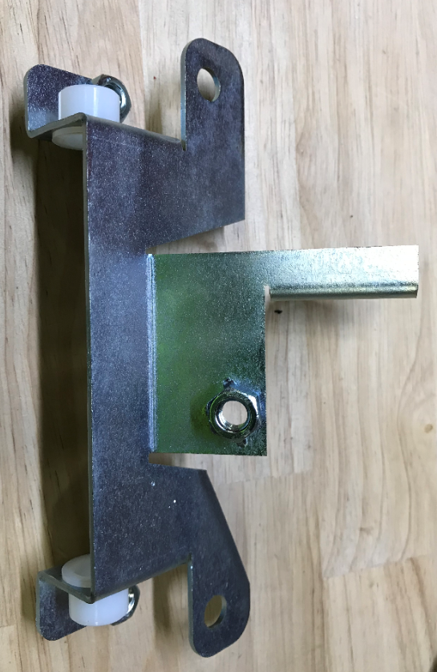
  - Take a handle bail weldment (E29335) and verify that the ends are in the proper alignment. The flats should be level or even pointed slightly upward. Green below is good and red is bad.

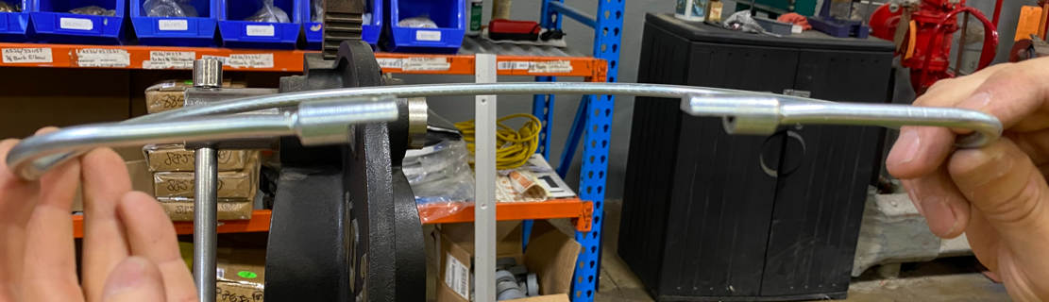
  - If the ends point down, clamp it in a vise as shown and tweak the end to get them level or slightly pointing up.
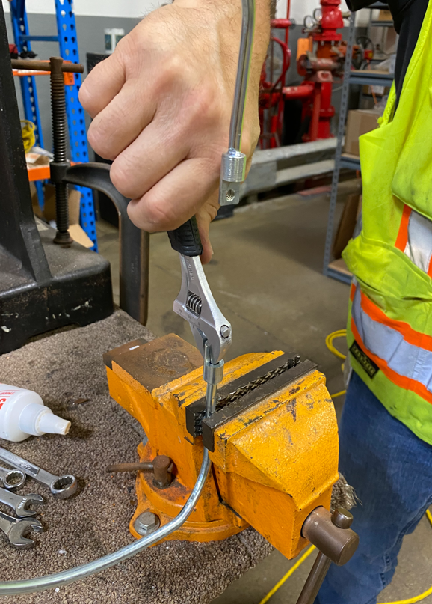

  - Once the bail is good insert the ends through the bushings into the appropriate orientation. Note the relation of the bend to the bracket.
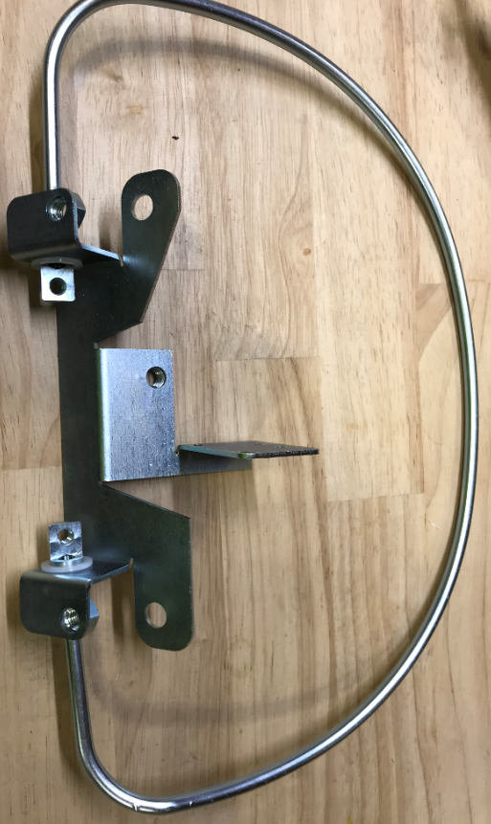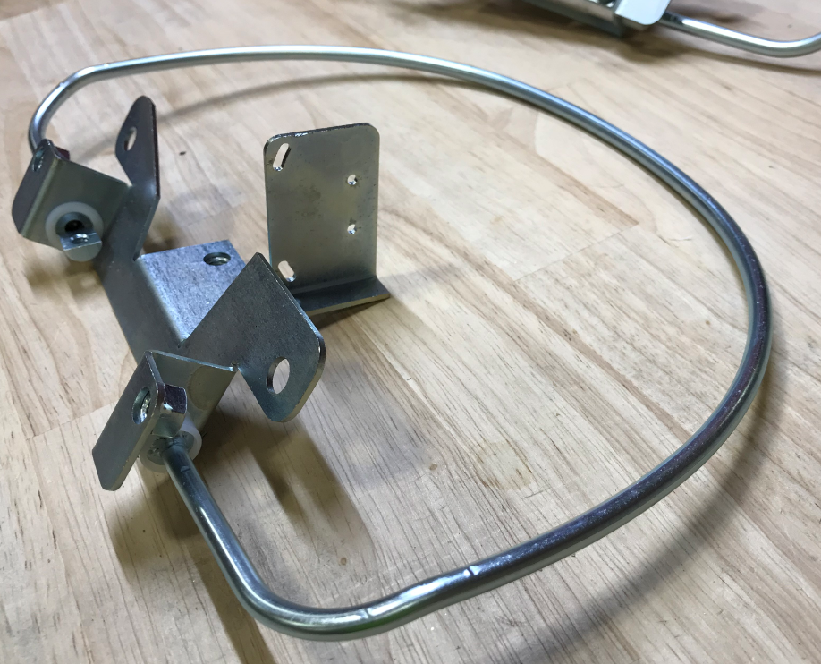

  - Place a bail pivot (E29326) into position.
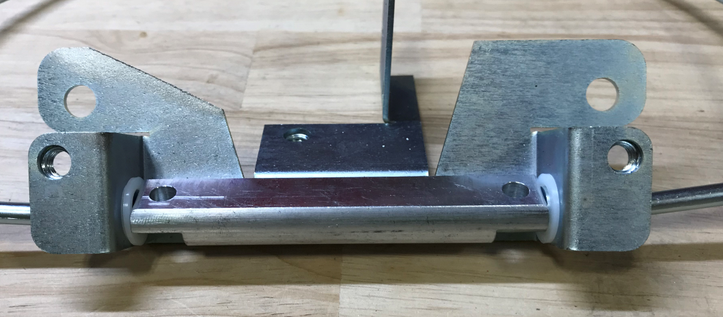
  - Place handle bail arm into the jig to verify fit and function. Attach a handle bail arm (E29327) to the pivot and bail using 2 bolts (E10734). Use Blue Loctite on the bolt threads. Ensure that the bolts are tight. Mark the orientation of the bolt heads with black marker.
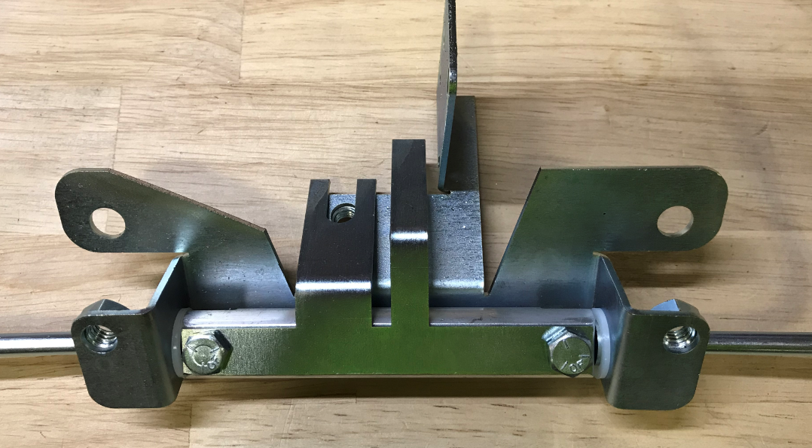
  - Take a spring (E29328) and place it over a hex bolt (E29329) then place a washer (28622) over the spring. Position the bolt with the tab of the bail arm on the washer.
-For a MSAS and a G20 traction unit, place another washer (28622) over the bolt and resting against the arm. Place a spring (29328) over the bolt and hand thread the bolt to the bracket.
-For a G20 pad assist unit, place a spacer (E28838) over the end of the bolt. Hand thread the bolt to the bracket.
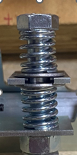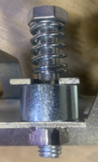
Washer
Spacer
Spring
G20 PA
MSAS/G20 TR
  - Secure the assembly in the fixture in the orientation shown. Clamp it in place.
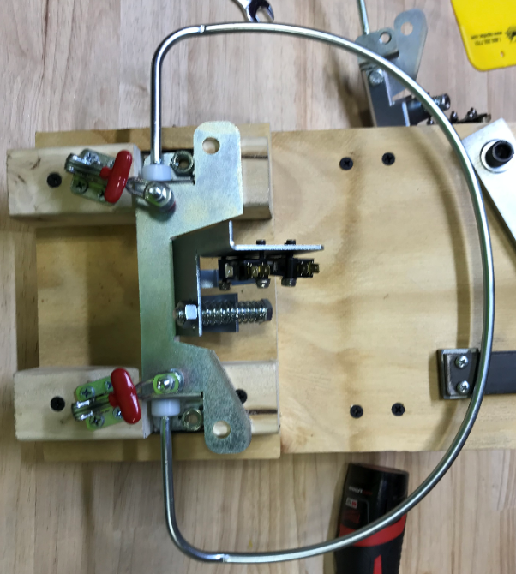
  - Adjust the screw with the springs so that the handle bail is lined up with the middle slot on the fixture. Place jam nut (E12524) onto the end of the screw and tighten. This marks the rest position of the assembly.

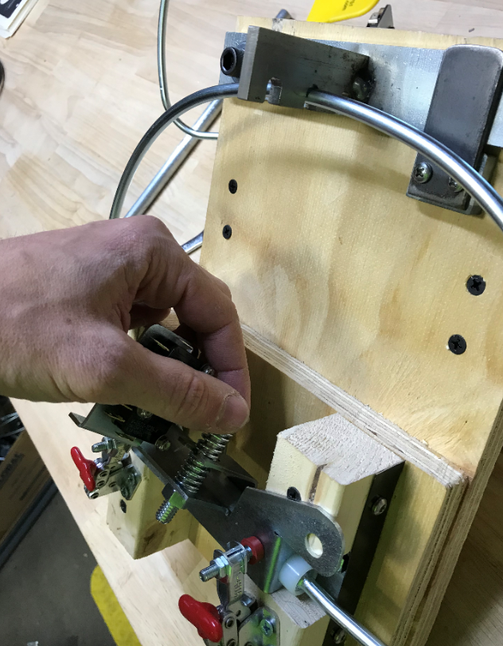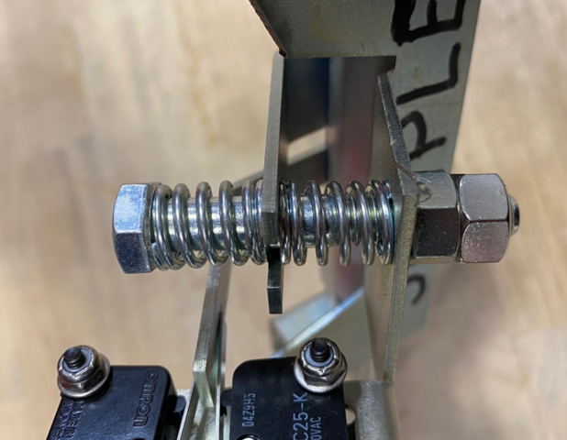

  - For a MSAS and a G20 Traction unit, attach 2 microswitches (E28669) finger tight. Use 2 screws (E28758) each with a toothed washer (E28821) under the screw heads. Use a flat washer (E29368) and a nut (E28770) on the other side.
-For a G20 Pad Assist unit, only use the top microswitch.
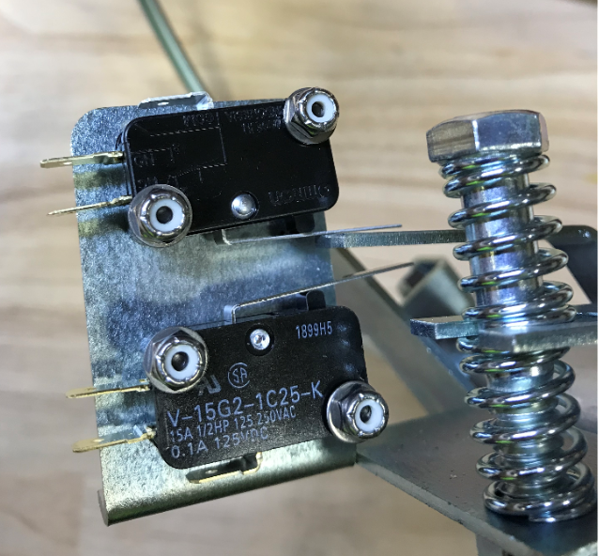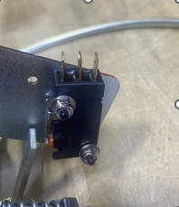
G20 PA
MSAS and G20 TR
  - Position the bail into the 3rd slot on the fixture bracket as shown. Push the top switch towards the tab until it engages (clicks). Once it does, tighten the screws.
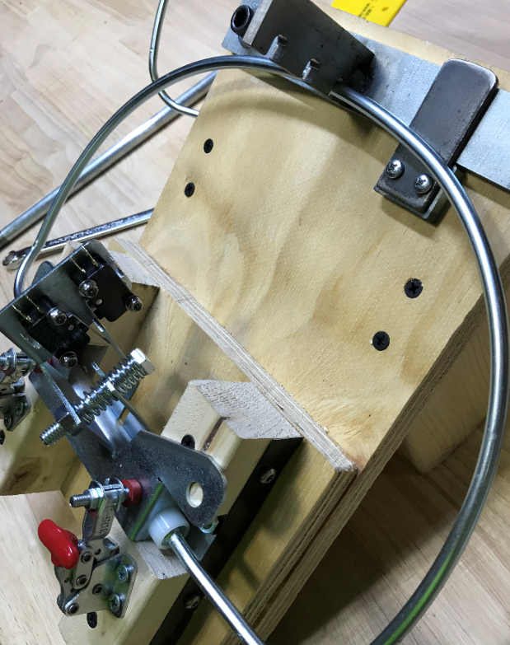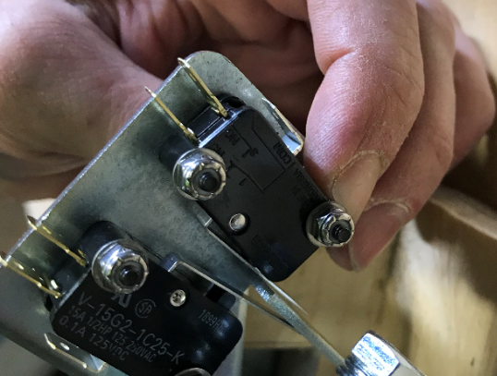
Rotate until a click is heard.
3rd Slot

  - Position the bail into the 1st slot on the fixture bracket as shown. Push the lower switch towards the tab until it engages, and you hear a click. Then slowly release until switch disengages and you hear a second click then tighten in place.
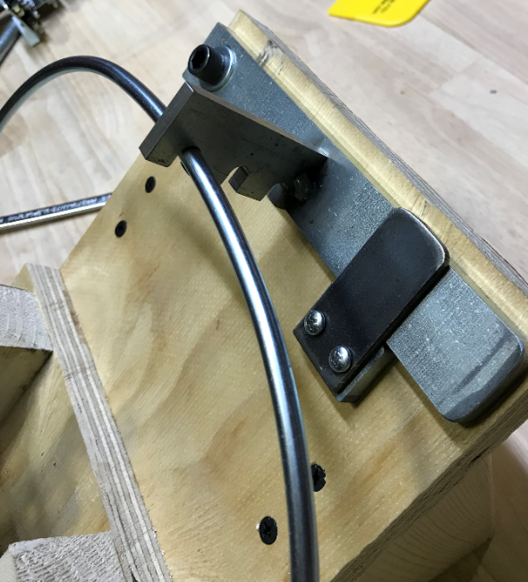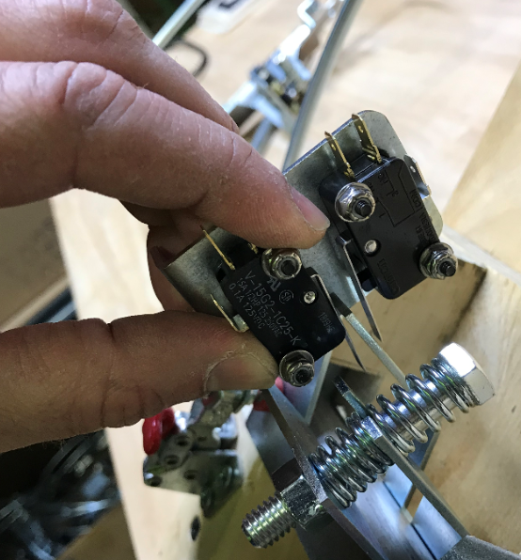
Rotate until a click is heard
1st slot
  - To check that the switch positions are accurate, move the fixture bracket just above the bail. Move the bail until the switch clicks in both directions. When the click happens, it should be aligned with the appropriate slot in the fixture bracket. Note: The bail should rest slightly above the 1st slot.
  - Mark the locations of the switches with a fine point mark in the locations shown.

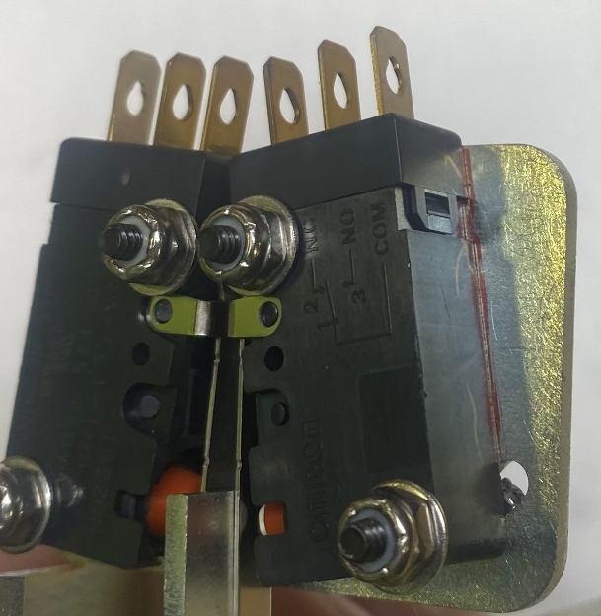

References (optional section as needed)
- Training Guide

Functional Training Groups Requiring Training
Equipment Assembly Group

- SOP Change Control

Date of Change | Reason for Change
Rev 01 | This is the first version of the S.O.P. hence there are no revisions to this document.
Rev 02 - 8/17/2021 | Added QC Checks and new switch setting procedure
Rev 03 - 11/1/2023 | Updated steps for current process.
Rev 04 - 7/17/2024 | Updated new part number and steps in process.
Rev 05 - 3/31/2025 | Combined MSAS and G20 instructions.
Rev 06 – 11/12/2025 | Updated red and green lines in step 2 for clarity

Approvals

Submitter/Author Approval:__________________________________ Date:______________________

Management Approval:______________________________________ Date:______________________

QAU Approval:_____________________________________________ Date:______________________

